The Text Editor made in java is named Edupad by us.

Design of Edupad:

Text Area

File Name (by default it is Untitled)

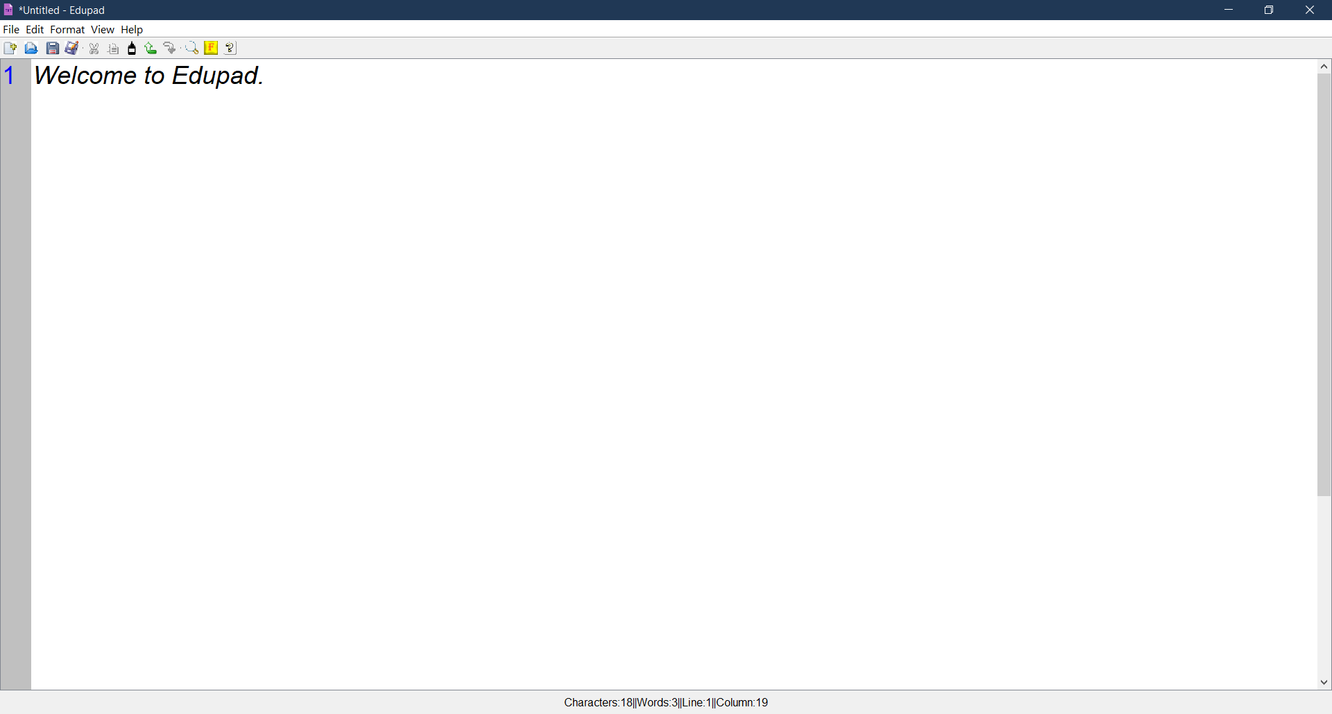

Line Number

Tool Bar

Menu Bar

Status Bar

File Option:

File option is the main menu in any text editor because it provides the main features such as saving, opening, printing and other options. It can be accessed by clicking on it or by pressing ALT + F.

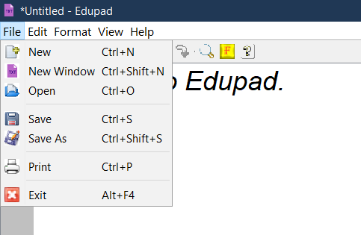

File menu contains:

1. New
2. New Window
3. Open
4. Save
5. Save As
6. Print
7. Exit

Edit Menu:

Edit menu in any text editor provides the features of undoing, redoing, cut, copy, paste and select all type features; that are too important to do work related with other resources. It can be accessed by clicking on it or by pressing ALT + E.

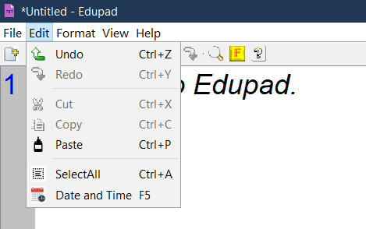

Edit menu contains:

1. Undo
2. Redo
3. Cut
4. Copy
5. Paste
6. Select All
7. Date and Time

Format Menu:

Style menu in any text editor is optional but it must be used in the good text editor because it provides the functionality to change page color, font’s color, size and family. It can be accessed by clicking on it or by pressing ALT + S.

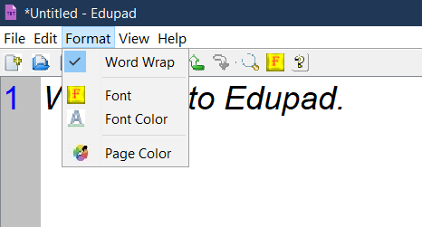

Format menu contains:

1. Word Wrap
2. Font
3. Font Color
4. Page Color

View menu:

View menu gives the option to zoom, find, show status bar and line number option.

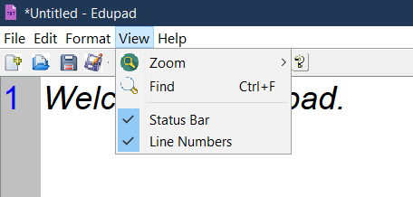

View menu options:

1. Zoom
   1. Zoom In
   2. Zoom Out
   3. Default Scale
2. Find
3. Status Bar
4. Line Numbers

Help menu:

Help menu gives the option to read the tutorial and also provides the feedback option so that user can also participate in to make it effective. It can be accessed by clicking on it or by pressing ALT + H.

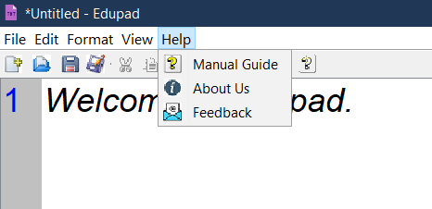

Help menu contains:

1. Manual Guide
2. About Us
3. Feedback

Tool Bar:

Tool bar provides the quick access to the commonly used menu items like New, Open, Save, Save As, Cut, Copy, Paste, Zoom, Find, Font, Help and others.



Status Bar:

Status bar provides the number of characters and words, number of lines and column (tells about the number of characters in one line whereas characters display the number of characters in all lines in the page).



Special Features of Edupad:

1. Enhanced looking through icons
2. Smart tool bar options
3. Line number option which makes it easy to locate line
4. Page and Font color option for better looking
5. Popup menu option for better and easy use
6. Provided the font, word wrap, print option that make it perfect Text Editor
7. Provided the special Google search option that searches whatever user wrote in the Edupad.
8. Provided the feedback option which able user to provide their valuable feedback to us.
9. Provided the manual guide option so that user can read it and use Edupad application easily.

Developer: Sushil Jangid BCA III Year 2019 Batch SMPGC

Support: sushiljangid69@gmail.com